Curriculum vitae
* PERSONAL INFORMATION
*Family name, First name: | Wenjun, Lu
*Date of birth: | 20.05.1985 | *Sex: | Male
*Nationality: | Norwegian
Researcher unique identifier(s)  (ORCID, ResearcherID, etc.): | ORCID: https://orcid.org/0000-0001-5153-7041  Scopus: 55861171800
URL for personal website: | https://www.ntnu.edu/employees/wenjun.lu
* EDUCATION
 | Name of faculty/department, name of university/institution, country
03.12.2014 | Ph.D. Department of Civil and Environmental Engineering, NTNU, Norway
2010 | Master (joint degree)  Department of Civil and Environmental Engineering, NTNU, Norway;  Civil Engineering and Geoscience, Technical University of Delft, the Netherlands;  Engineering and Physical Sciences, University of Southampton, UK.

CAREER BREAKS
12.03.2021- 19.08.2021 | Parental Leave

SUBTRACTING TIME FROM AGE/PERIOD AFTER DOCTORAL DEFENCE
Date of doctoral defence: |  | 03.12.2014
Time subtracted from period after date of doctoral defence (for the approved doctoral degree):
12.03.2021 | 19.08.2021 | Documented? (Yes)

* POSITIONS
Current Position
2021- | Associate Professor - Faculty of Engineering Science and Technology,  Department of Civil and Environmental Engineering, NTNU - Norway
Previous positions held (list)
2018-2021 | Senior Researcher (Forsker II) - Faculty of Engineering Science and Technology,  Department of Civil and Environmental Engineering, NTNU - Norway
2014-2018 | Postdoctoral Researcher - Faculty of Engineering Science and Technology, Department  of Civil and Environmental Engineering, NTNU - Norway
FELLOWSHIPS, AWARDS AND PRIZES
2018-2021 | Vista Scholar, a prestigious 3-year research funding from the Norwegian Academy of Science and Letters for basic mathematical and scientific research.
2015 | Chorafas Foundation Prize (5,000 USD) for the best doctoral thesis at NTNU within all faculties (the only award winner among ~340 theses of the year 2014).
2014 | Chinese Government Award for Outstanding Students Aboard (6,000 USD). This is a worldwide, all discipline inclusive, annual award given to 500 highly-sought Chinese PhDs, who have studied abroad without funding source in connection with China
2013 | Best paper award (800 Euros) on the 22nd International Conference of Port and Ocean Engineering under Arctic Conditions (POAC), Espoo, Finland
2012 | Best paper award during the 21st International Conference of IAHR Symposium on Ice, Dalian, China
2008-2010 | Erasmus Mundus scholarship (42,000 Euros) for a two-year joint MSc program in EU, with funding from the European Commission.
PROJECT MANAGEMENT EXPERIENCE
 | Project and role, funding from
2019 | Project manager for ‘Structural safety in the high North: Load, Design and Operation of Floaters in the Norther Area (NORD ST20) 2019/313’ from the Petroleum Safety Authority Norway (Petroleumstilsynet).
2019-2020 | Project manager for ‘Glacial Ice Action: Executive summary of NORD ST20 209/313 and NORD ST19’ from the Petroleum Safety Authority Norway (Petroleumstilsynet)
2018-2021 | Project manager of the VISTA SCHOLAR from the Norwegian Academy of Science and Letters (DNVA)
2016 | Co-project manager of the ‘model-scale test of the GBS towing operations’ with funding from the industry, (KVAERNER AS, Now Arker Solution)
2016-2018 | Co-project manager of the ‘large-scale field ice fracture experiments’ (SAMCoT)
2019 | Work package leader for ‘Assessment of Structural Damage due to Glacial Ice Impact’ with funding from the Petroleum Safety Authority Norway (Petroleumstilsynet)
SUPERVISION OF GRADUATE STUDENTS AND RESEARCH FELLOWS
 | No. of | Master’s students/ Ph.D./Postdocs | Name of faculty/department/centre, name of university/institution/country
2012-2016 | 3 | MSc | NTNU/ Faculty of Engineering Science and Technology, Department of Civil and Environmental Engineering-Norway
2019-2020 | 1 | Visiting Postdoc
2015 -2019 | 3 | Visiting Ph.D.
TEACHING ACTIVITIES
 | Teaching position – topic, name of university/institution/country
2018 - | Lecture in ‘Ice Mechanics’ at NTNU, Norway
2018 - | Lecturer in ‘Arctic Offshore Engineering (AT 327)’ and ‘Field course’ (AT 327F)’ at UNIS, Svalbard, Norway
Other relevant professional experiences
Year | Description - Role
2020 | One of the organisers of the 25th IAHR International Symposium on Ice, Trondheim
2015 | One of the organisers of the 23rd International conference on Port and Ocean Engineering under Arctic conditions (POAC)
2012 - | Frequent reviewers of major conference papers and journal papers in ice related topics.
Early achievements track record
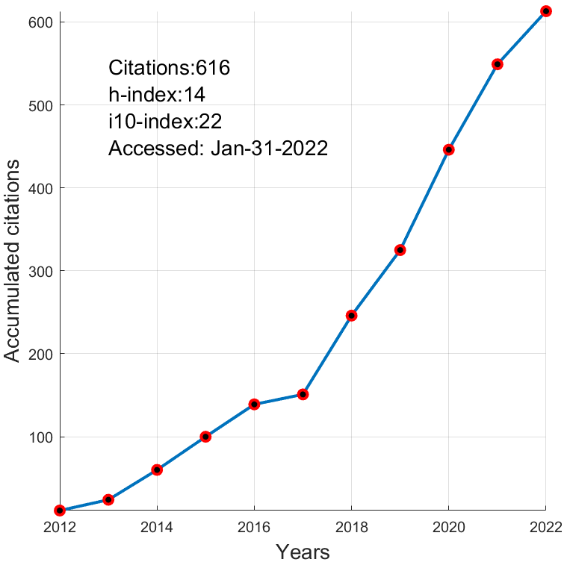
The total number of publications during the career:
- International Journal Papers: 19
- International conference Papers: 30
- Technical Reports: 11; Theses: 2; Book contribution: 3
- A list of up to five publications in major national or international peer-reviewed journals
- LU, W., Ice Fracture. IUTAM Symposium on Physics and Mechanics on Sea Ice. Springer 2022 ISBN 978-3-030-80439-8. s. 75-100
- Kellner,L., LU, W., et al. Study on the cohesive edge crack in a square plate with the cohesive element method. International Journal of Fracture 2021;
- LU, W., LUBBAD, R., SHESTOV, A. & LØSET, S. 2018. Parallel channels' fracturing mechanism during ice management operations. Part I: Theory. Cold Regions Science and Technology (CRST), 102-116.
- LU, W., LUBBAD, R. & LØSET, S. 2018. Parallel channels' fracturing mechanism during ice management operations. Part II: Experiment. CRST.
- LU, W., LUBBAD, R., LØSET, S. & KASHAFUTDINOV, M. 2016. Fracture of an ice floe: Local out-of-plane flexural failures versus global in-plane splitting failure. CRST, 123.
- Innovation with societal impact
- Cofounder and developer of ArcISo AS, a spin-off company from the SFI research centre of Sustainable Arctic Marine and Coastal Technology (SAMCoT)
- Report: LU, W et al., Estimation of Ice Actions on the Grounded Trawler Northguider in the Hinlopen Strait, 2019, a report to assist the Coastal Administration on the salvage operation of Northguider.
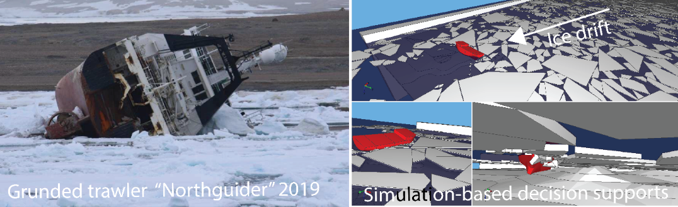

- Leadership of field work or research expeditions
Year | Description of the field work or research expedition
2015, 2016, 2017, and 2018 | Co-Project leader, Four Large-scale field ice fracture experiments to extract the cohesive fracture properties of sea ice (Svea, Svalbard)
2012, 2013, and 2015 | Work package leader, Three Oden Arctic Technology Research (Arctic Ocean)
2012 | Participant, KV-Svalbard Research Cruise dataset (Arctic Ocean)
- Invited presentations to peer-reviewed national or international conferences and/or international advanced schools.
Year | Invited talks
December 2017 | ‘Large-scale Field Ice Fracture Experiments for Fracture Properties of Sea Ice’ at the workshop ‘Ice fracture and cracks, SIPW04’ at Isaac Newton Institute for Mathematical Science, University of Cambridge, Cambridge, UK.  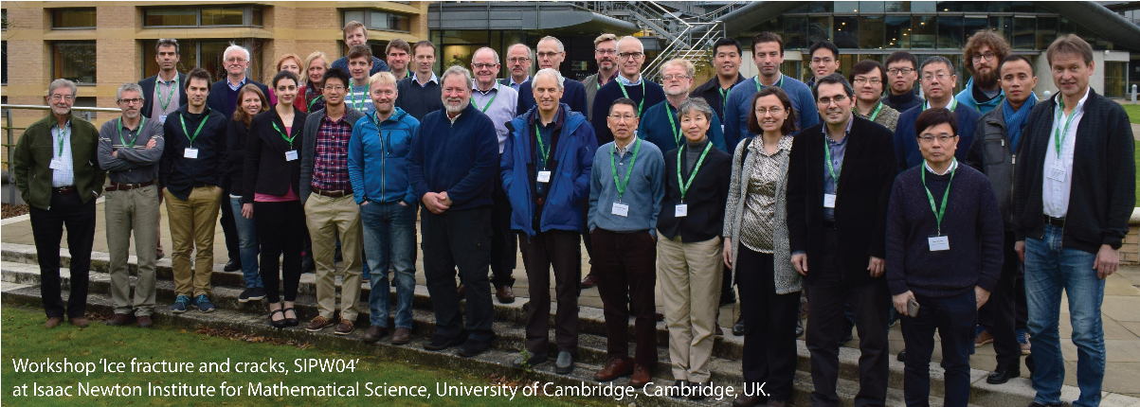
June 2016 | ‘ice fracture’ at the IUTAM Symposium on Physics and Mechanics of Sea ice, Espoo, Finland
December 2018 | ‘Ice Fracture Simulations within SAMS’ in the session ‘Arctic Science’ during the Arctic Partnership Week in Busan, South Korea
June 2017 | ‘Fracture properties of sea ice: an inquiry from different scales’ at the Workshop on X-ray micro-tomography of porous ice media, NTNU, Trondheim, Norway

