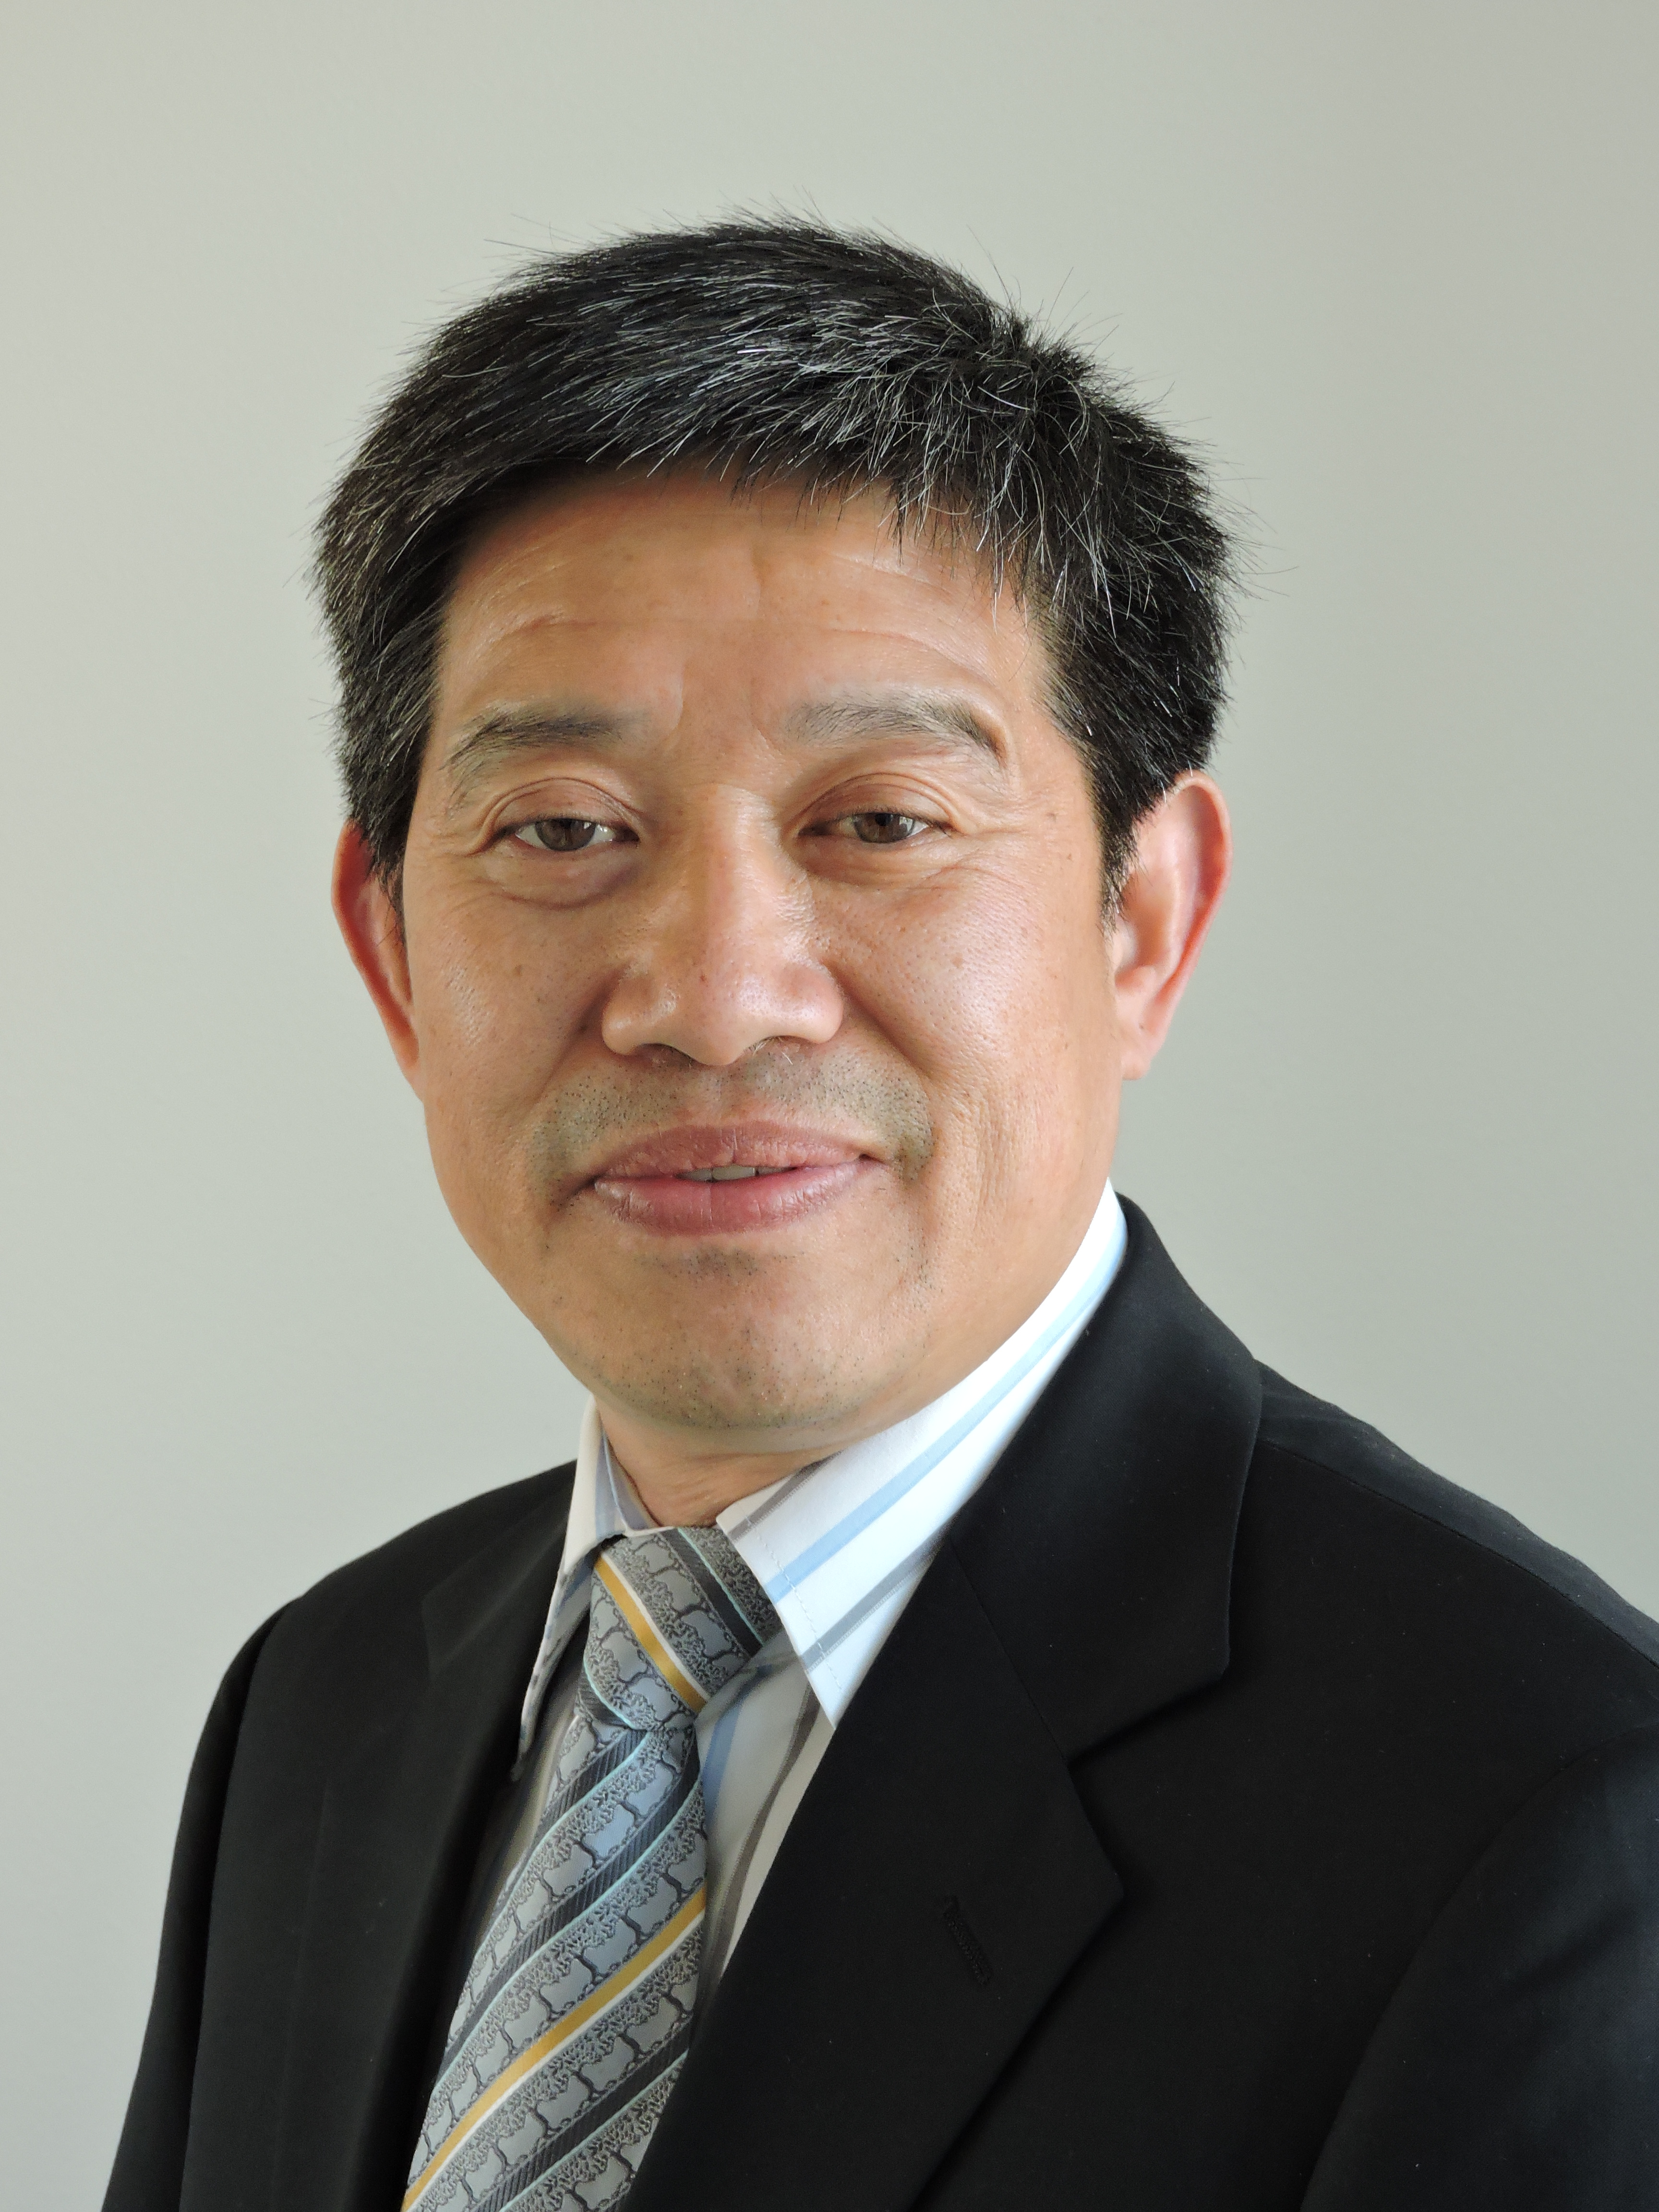

De Chen

Department of Chemical Engineering
Norwegian University of Science and Technology

Dr. De Chen is a professor in catalysis at the Department of Chemical Engineering, Norwegian University of Science and Technology (NTNU) since 2001 (associate professor 1998-2001). He earned his PhD in industrial catalysis at NTNU, Norway, in 1998. He was a visiting professor at the University of California at Berkeley (2009-2010) and East China University of Science and Technology (2017-2018). His research is mainly on a multiscale approach at the interface between catalysis science and industrial chemical processes. His work on combined theoretic and experimental heterogeneous catalysis has in several instances led to the development of new catalysts for gas to liquids, monomer production for polyvinyl chloride (PVC), biomass to liquids, natural gas to olefins, hydrogen production and fuels, as well as materials for CO₂ capture technologies, plastic waste recycling and energy storages. He is a member of the Norwegian Academy of Technological Science and the Royal Norwegian Academy of Sciences and Letters, as well as the Academy of Europe. He is the director of the innovation hub for the upcycling of wastes, a member of the leader group at the National Innovation Center (iCSI), and FME Center of biomass for fuels (Bio4Fuels). He published more than 450 scientific papers in pre-reviewed journals (H-index:87) and more than 15 patents.

