
Bild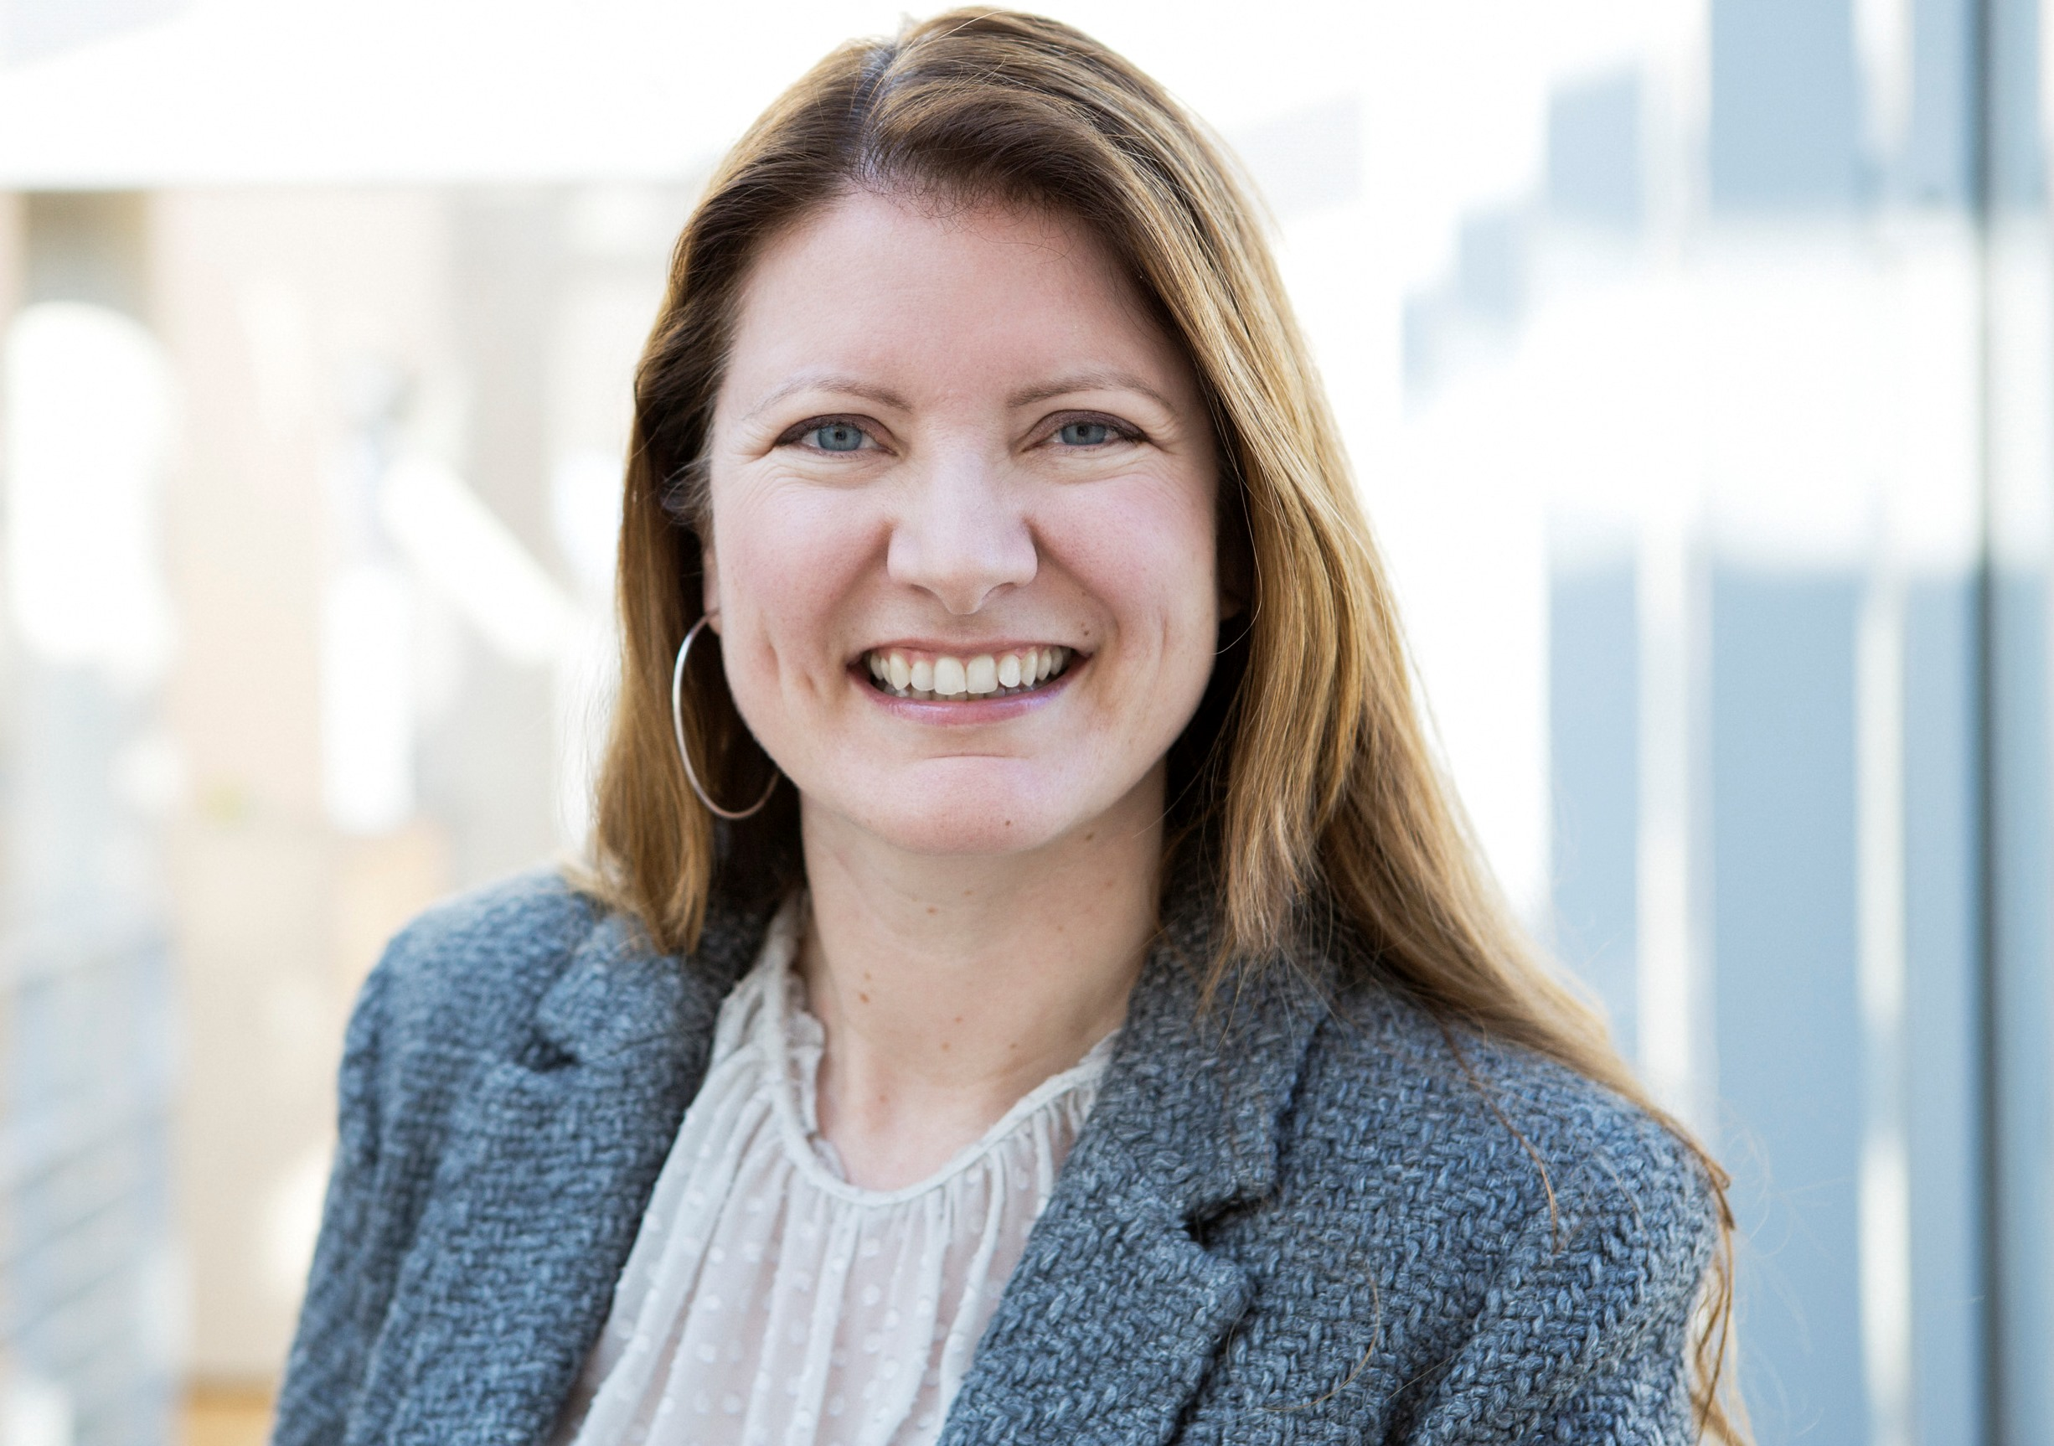e (Optional)

Name: Siv Marina Flø Grimstad

Current position (Main employer): Associate Professor

Teaching areas: International Marketing (bachelor), international business and marketing (master), sustainable development (master)

Teaching and/or course coordinating responsibilities 2022/2023 at NTNU-ØK (including supervision): AE511416 IBM, AM304016 Int.Mark, main supervisor for 2 mastergroups (4 students) and 2 phd-students.

Research Interests:

international entrepreneurship, corporate social responsibility, circular economy, international marketing, sustainability

Education (please include pedagogical training. E.g. PEDUP at NTNU):
Degree (PhD, MSc, BA etc) | Awarding Institutuon | Year | Subject area (e.g, Finance) | Title of thesis
PhD/Dr.oecon | Norwegian Business School, BI | 2006 | International marketing | The Born global - Redefined
Cand.merc | Norwegian School of Economics, NHH, Bergen) | 2000 | International marketing | The internationalisation process - a relationship approach
Bachelor with Honours (siv.øk) | Heriot Watt University | 1995
(Insert rows if needed)

Professional experience (previous and ongoing):
Position/title | Employer/place | Periode | Responsibilities/tasks (Short description)
Associate professor | Norwegian University of Science and Technology (NTNU) | 2017 - ongoing | Lectures, project coordination and supervision
Dean | Ålesund University College | 2012-2017 | Coordinating and managing the activities at the business department at ÅUC
Associate professor  (assistant professor from 2003-2006) | Oslo University College (today (OsloMet) | 2003-2012 | Lectures, supervision, responsible for coordinating the bachelor dissertations
(Insert rows if needed)

PhD Supervision:

Main supervisor for 1 phd-student since March 2022

Scientific committees (e.g. PhD assessment committees, expert committees):

Leader for a group evaluating the master in business administration at OsloMet (2023)

Leader for evaluating committee for a position as associate professor in the University of Southern Norway (2019)

Intellectual contributions 2018-2022

Articles in Peer Reviewed Journals:

Magnano, D.G., Grimstad, S.M.F., Glavee-Geo, R. & Anwar, F. (2024) Disentangling circular economy practices and firm’s sustainability performance: A systematic literature review of past achievements and future promises, Journal of Environmental Management, 353 (120138), 1-20.

Grimstad, S.M.F., Glavee-Geo, R., Soufiane, A. & Hameed, I. (2022). An Expert System for Systematic International Market Selection, International Journal of Export Marketing, Vol. 4, No. 4.

Grimstad, S. M. F., Glavee-Geo, R. & Fjørtoft, B. E. (2020), SMEs motivations for CSR: An exploratory study, European Business Review.

Fjørtoft, B. E., Glavee-Geo, R. & Grimstad, S. M. F. (2020), Motivations for CSR in the Norwegian maritime cluster: Stakeholder perspectives and policy implications, Maritime Policy and Management.

Scholarly books and chapters in scholarly books:
Grimstad, S.M. F., Ottosen, L. & James, N. (2023). Circular business models for SMEs in the Fishing Gear Industry. Marine plastics – innovative solutions to tackling waste, Springer.

Glavee-Geo, R., Uddin Al Ahmed, S.W., Tippett, A., Grimstad, S.M.F. & Pasquine, M. (2023). The role of non-profit organizations in value creation: the case of recycled fishing gear industry in Norway. Ch 9 in Grimstad, S.M.F., Ottosen, L. & James, N. (eds.) Marine plastics – innovative solutions to tackling waste, Springer.

Glavee-Geo, R., Grimstad, S.M. F., Al Ahmed, S.W.U. & Engeseth, M. (2023). Circular business models for SMEs in the Fishing Gear Industry. Ch 4 in Grimstad, S.M.F., Ottosen, L. & James, N. (eds.) Marine plastics – innovative solutions to tackling waste, Springer.

Hagen, M.F., Lund, E.A.L., Fjørtoft, B.E., Grimstad, S.M.F. & Glavee-Geo, R. (2021), Kan bærekraftige fritidsreiser gi en bedre reiseopplevelse?,kap. 4, Bidrag innen kundeverdi og marked : Festskrift til Øyvind Helgesen, Universitetsforlaget s. 73-88.

Fjørtoft, B. E., Grimstad, S. M. F. & Glavee-Geo, R. (2019) Utvikling av en modell for samfunnsansvar i den maritime næringen. Modeller: Fjordantologien.
Karlsen, S.M.F., Zhao, Y & Lunnan, R. A Comparison of Norwegian and Chinese Born Globals, in Marinov, M (ed.) Internationalization of Emerging Economies and Firms, Palgrave MacMillan, 2012.
Karlsen, S.M.F. Ledelsesansvar og styringsproblem knyttet til bedrifters samfunnsansvar, i Ladegård, G. og Vabo, S. (red.) Ledelse og Styring, Fagbokforlaget, 2010.
Karlsen, S.M. The Internationalization Process: 12 cases, in Benito, G.R.G. & Narula, R. (eds.) Multinationals in the Periphery, Palgrave MacMillan, 2007.

textbooks, professional books etc (not fiction):

ConferEnce lectures and academic presentations:
Presented papers at the Annual European International Business Academy (EIBA) in Oslo (2022), Milan (2017), Uppsala (2014), Porto (2010), Catania (2007), Oslo (2005), Copenhagen (2003), Athens (2002) and Paris (2001).

REports, Case development, teaching material etc.:
Karlsen, S.M. The internationalization: a relationship approach, SNF-
report, No 20/00, 2000.

Nordgård, K., Fensgård, K. & Karlsen, S.M.F. Motepilot, en undersøkelse av det norske motedesignfeltet, Norsk Form, 2008.

Dissemination activities outside academia:
Regiostar finalist in Oct 2020 with the BCE-project.
NRK pitch in Nov 2020 on plastics in the ocean issues.
Karlsen, S.M. (2010). Seige holdninger til samfunnsansvar. Kronikk.
Ny Tid 29 (ISSN 0803-3498), 34-35.

Reviewing activities (incl. editorial):
Editor for an anthology at Springer in the spring 2023.

OTher intellectual contributions:

Successful Grant applications and other awards:

Administrative roles related to your academic position:
Project coordinator for the cross-discplinary, internally funded project, ”Combining skills to identify the ”sweet spot” to solve marine platic pollution in Norway” (2022-2026).
Work package leader in the EU-funded Interreg project ”CIRCNETS” (2023-2026) with 5 partners from 5 nations (Ireland, Greenland, Scotland, England and Norway).
Project coordinator for a bridging project (also Interreg), ”Blue Circular Tech” (Jan 2022-June 2022).
Project coordinator for the EU-funded Interreg project Blue Circular Economy (2018-2022).

Professional Development in pedagogy and didactics:
A fifteen study point pedagogical course was taken when I was employed at Oslo University College in 2004. This was compulsory for newly employed faculty staff.

Two modules at NTNU were completed on writing a pedagogical portfolio on May 29th and August 18th in 2020.
In addition, a module on PhD-supervision was completed in June-November 2020.

Ongoing experiences might include adjunct professor at other institutions, consultancy work, board service etc.
List all your intellectual contributions in this period. Any contribution that fall into one of the categories of Cristin should be listed. Other intellectual contributions may also be listed.
Presentations for professional organizations/bodies, popular science presentations/publications, chronicles, interviews, encyclopedia articles etc.
Other contributions to demonstrate your sustained engagement and maintenance of your academic currency
E.g. Program manager, development taskforces, working groups, serving on professional boards/bodies, serving in evaluation committees, hiring committees etc

